# IIS and Uploading Files

You may run into an issue where after uploading a file through PHP running on IIS, that the file has security settings your Windows account is not allowed to see.

You may be unable to delete the file and changing permissions may be a huge hassle.

This is caused by PHP defaulting to upload temporary files to c:\windows\temp

When the uploaded files are moved, they have the permissions from windows\temp applied to them which are very strict.

To resolve this issue, create a folder somewhere else on your system and update php.ini

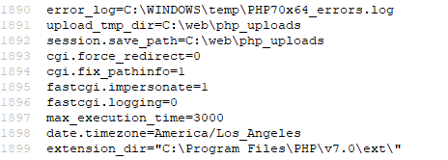

Upload_tmp_dir and session.save_path have both been moved to a directly with less strict permission. Now when you upload files through the web using PHP, the permissions on the resulting file will be the same as the permissions on your folder.

The easy way to apply these changes is to open CMD as an administrator and run iisreset